**Wall Follower Robot**

**Name: Brijbhan Govardhan Prajapati (C3084787)**

**University: Sheffield Hallam University**

**Subject: Cognitive system and Robotics**

Index:

1. Abstract
2. Introduction
3. Literature Review
4. Description of Implementation
   1. Initialization
   2. Sensor Setup
   3. Main Control Loop
   4. Wall-Following Function
   5. Velocity Control
   6. Debugging and Testing
   7. Functionality and Improvements/Changes
   8. Justification of Robot Choice
   9. Supporting Documentation
5. Advantages and Disadvantages
6. Use of the E-puck Robot in the Real World
7. Ethical Implications
8. Conclusions
9. References

Abstract:

This project explores the development and implementation of a wall-following function for the e-puck robot inside the Webots test system environment. The essential objective is to create an independent route calculation that enables the e-puck robot to follow walls in its environmental factors effectively. By using vicinity sensors and camera input, the robot perceives its environment and changes its trajectory as needed to avoid walls.

The project begins with a literature review, giving context and inspiration to the chosen task. It then proceeds to describe the implementation exhaustively, including the usefulness of the developed routine and any improvements or changes made during the development process. Screenshots, code snippets, and charts are provided to illustrate key concepts.

The advantages and disadvantages of utilizing the e-puck robot and Webots environment are discussed, alongside potential real-world uses of the developed wall-following. Ethical ramifications related to robotic independence and societal effects are additionally considered.

The project concludes with reflections on the discoveries and bits of knowledge gained, alongside suggestions for future research directions. Through this exploration, the project plans to contribute to the advancement of robotics education and research, displaying the capabilities of simple yet versatile robots like the e-puck and featuring the potential uses of independent route calculations in different areas.

**Keywords**: E-puck robot, Wall-following function, independent route, Webots simulator, proximity sensors, Camera input, Robotics education, Real-world applications, Ethical implications

Introduction:

The implementation of a wall-following function for the e-puck robot in the Webots test system represents a fundamental exploration into robotic route and control. The essential objective of this project is to develop a hearty and adaptive calculation that enables the e-puck robot to independently follow walls in its environment. This copies a typical strategy observed in nature and has commonsense applications in different fields, including robotics research, modern robotization, and educational robotics.

By leveraging vicinity sensors and camera input, the e-puck robot is equipped to perceive its environmental elements and make informed decisions about its movement. The wall-following routine developed for this project utilizes sensor information to detect obstacles, determine the robot's position relative to the walls, and change its trajectory as needed. Through iterative testing and refinement, the calculation intends to achieve smooth and efficient wall-following performance across different environmental circumstances.

The choice of the e-puck robot for this project is motivated by its reduced size, moderateness, and versatility. As a well-known educational stage, the e-puck offers a commonsense and accessible means for students and researchers to explore concepts in robotics, sensor combinations, and independent routes. Furthermore, the Webots test system provides a realistic virtual environment for testing and approving the developed calculation before deployment on actual hardware.

This project seeks to contribute to the assemblage of knowledge in robotics by demonstrating the feasibility and effectiveness of wall-following functions utilizing simple yet powerful sensor-equipped robots like the e-puck. Through experimentation and examination, bits of knowledge gained from this project can illuminate future research endeavours and inspire innovative answers for real-world challenges in robotics and mechanization.

Overall, this project serves as a fundamental exploration into independent route calculations, displaying the capabilities of the e-puck robot and featuring the potential uses of wall-following behaviours in different spaces. By documenting the implementation process and sharing bits of knowledge gained from this project, we intend to contribute to the advancement of robotics education and research, fostering a deeper understanding of intelligent robotic systems and their pragmatic ramifications.

Literature Review:

The development of wall-following features in robotics has been a subject of extensive research and exploration due to its significance in independent route undertakings. Numerous studies have investigated different approaches and techniques to enable robots to effectively follow walls in diverse environments.

These estimations provide simple yet effective strategies for robots to navigate along walls by keeping a consistent separation and direction relative to the nearest wall. However, they could exhibit restrictions in complex environments with irregular obstacles or confined spaces.

Advancements in sensor technology have facilitated the development of more sophisticated wall-following computations. Closeness sensors, for example, infrared and ultrasonic sensors, enable robots to detect obstacles and walls in their area with greater exactness and reliability. Furthermore, the integration of camera systems enhances the robot's perception capabilities, thinking about visual feedback and environmental preparation.

Machine learning techniques, especially reinforcement learning and neural networks, have been applied to optimize wall-following action. These approaches enable robots to change and learn for reality, further developing their route performance in unique and uncertain environments.

The choice of the robot stage assumes a critical part in the implementation of wall-following behaviours. Reduced and agile robots, for example, the e-puck, offer versatility and manoeuvrability, making them well-suited for assignments requiring precise routes in constrained spaces. Furthermore, recreation environments like Webots provide a realistic and scalable stage for testing and supporting computations before deployment on genuine hardware.

Motivation for the Chosen Project:

Wall-following behaviours are fundamental to numerous robotic applications, including exploration, surveillance, and coordinated factors. By zeroing in on the development of a wall-following behaviour for the e-puck robot, this project intends to address real-world challenges in robotics education and research.

The e-puck robot offers an ideal stage for experimenting with wall-following computations due to its smaller size, reasonableness, and versatility. As a well-known educational contraption, the e-puck provides students and researchers with involved experience in robotics programming

and computation development. Moreover, the Webots test system provides a realistic virtual environment for testing and refining computations before deployment on genuine hardware.

By exploring and implementing wall-following behaviours on the e-puck stage, this project seeks to contribute to the advancement of robotics education and research. The developed estimation can serve as an essential structure block for more complex route errands, moving further exploration and development in the field of independent robotics.

Description of Implementation:

The implementation of the wall-following behaviour for the e-puck robot encompasses several vital elements, including functionality, improvements, and supporting documentation. Below is a detailed overview:

Functionality: The implemented wall-following behaviour permits the e-puck robot to independently navigate and follow walls in its environment. Utilizing information from its vicinity sensors and camera, the robot determines its position relative to nearby walls and changes its trajectory in like manner. The behaviour includes arrangements for turning when encountering obstacles, maintaining a consistent distance from walls, and changing its way to efficiently navigate corners.

Improvements/Changes: All through the development process, several improvements and adjustments were made to enhance the performance and robustness of the wall-following behaviour. These include fine-tuning sensor thresholds, advancing velocity control mechanisms, and refining decision-production calculations. Also, debugging and testing procedures were implemented to identify and address any issues or inconsistencies in the behaviour.

Justification of Robot Choice: The e-puck robot was chosen for its appropriateness as an educational stage and its versatility in robotic experimentation. Its minimized size, moderateness, and comprehensive sensor suite make it an ideal choice for developing and testing independent route calculations. Furthermore, the e-puck's similarity with the Webots test system provides a realistic and scalable environment for mimicking and approving robotic behaviours before deployment on actual hardware.

Supporting Documentation: Documentation of the development process includes design ideas, environment setup, and results examination. Design ideas outline the conceptual framework and objectives of the wall-following behaviour, giving knowledge into the development objectives and strategies. Environment setup details the arrangement of the reproduction environment inside Webots, including the placement of obstacles, walls, and the e-puck robot. Results examination involves evaluating the performance of the implemented behaviour through quantitative metrics and qualitative observations, supported by information investigation, screenshots, and perceptions.

In outline, the implementation of the wall-following behaviour for the e-puck robot involves a systematic way to deal with calculation development, testing, and documentation. Through iterative refinement and examination, the behaviour demonstrates the effectiveness and feasibility of independent routes in constrained environments, supported by comprehensive documentation of the development process and results.

Initialization: The implementation begins with installing the e-puck robot inside the Webots test system environment. This involves stacking the e-puck model, designing recreation parameters, and setting up the necessary sensors and actuators. During this stage, the robot is prepared for operation, ensuring that all components are properly initialized and ready for use.

Sensor Setup: The e-puck robot is equipped with closeness sensors and a camera, which serve as its essential means of perceiving the environment. The Sensor Setup phase involves designing these sensors to provide accurate and reliable information to the robot's control system. Adjustment and alignment might be performed to ensure ideal sensor performance, limiting noise and augmenting detection exactness.

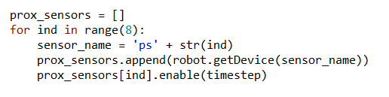

Main Control Loop: The Main Control Loop frames the core of the implementation, governing the robot's behaviour and decision-production process. This loop iterates at regular time intervals, permitting the robot to constantly process sensor information, make decisions, and execute activities. Inside the control loop, calculations for obstacle detection, way arranging, and velocity control are implemented to enable the robot to navigate independently.

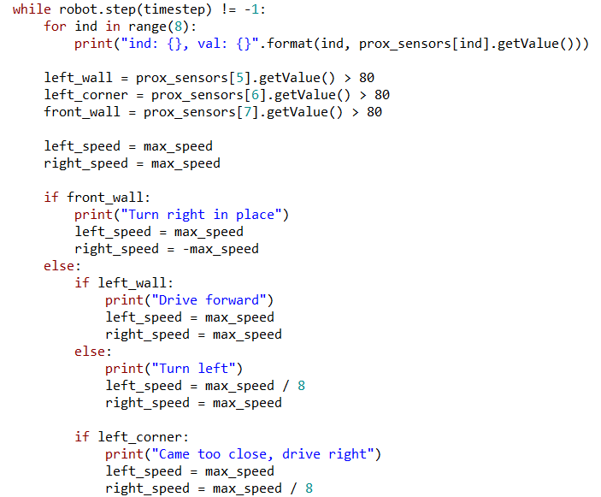

Wall-Following Behaviour: The Wall-Following Behaviour is a key aspect of the implementation, enabling the robot to follow walls in its environment. Utilizing information from its closeness sensors and camera, the robot determines its position relative to nearby walls and changes its trajectory appropriately. The behaviour includes arrangements for turning when encountering obstacles, maintaining a steady distance from walls, and changing its way to efficiently navigate corners.

Velocity Control: Robot movement is controlled in terms of both direction and speed using velocity control mechanisms. Through the control of wheel velocities, the robot can perform various actions such as braking, turning, and driving forward. The main control loop incorporates velocity control calculations, allowing the robot to gradually alter its speed in response to its current condition and external factors.

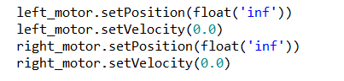

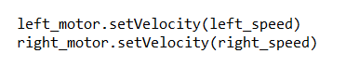

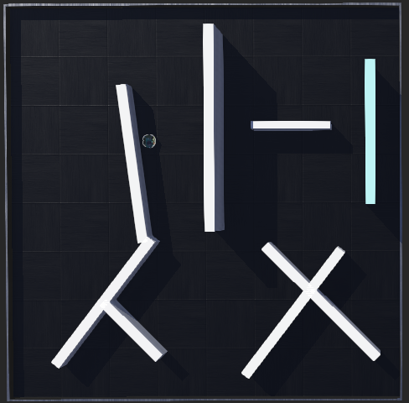

ADVANTAGE AND DISADVANTAGES:

## **Advantages**

**Versatility**: The e-puck robot might be used for a lot of schooling and research purposes due to its flexibility and versatility.

**Moderateness**: the e-puck robot is a very minimal expense in contrast with other robotic researchers and students on a limited budget can use the e-puck robot.

**Sensor Suite**: The e-puck robot is equipped with a comprehensive sensor suite, including vicinity sensors and a camera. These sensors provide valuable information for perception and route errands, enabling the robot to effectively interact with its environment.

**Webots Simulator Compatibility**: The e-puck robot is compatible with the Webots simulator, which provides a realistic and scalable environment for testing and approving calculations. Reproduction takes into account quick prototyping and experimentation without the need for actual hardware.

**Educational Value**: The e-puck robot serves as a valuable educational device for teaching concepts in robotics, programming, and man-made consciousness. Its straightforwardness and accessibility make it ideal for acquainting students with the principles of robotics and encouraging involved learning.

## **Disadvantages**

**Limited Processing Power**: The computational capabilities of the e-puck robot are relatively modest compared to more powerful robotic stages. This constraint might restrict the complexity of calculations that can be implemented by installing the robot.

**Limited movement**: Despite being nimble and nimble, the e-puck robot's movement is constrained when compared to bigger robots with stronger actuators.

**Limited Battery Life**: The e-puck robot operates on battery power, which might have limited capacity and endurance. Depending on the errand and operating conditions, the robot's battery life might be a restricting variable in its performance and independence.

**Sensitivity to Environmental Conditions**: The performance of the e-puck robot might be sensitive to environmental conditions like lighting, surface texture, and obstacle geometry. Varieties in these variables might affect sensor readings and calculation performance, requiring careful alignment and variation.

Use of this Robot in the Real World:

The e-puck robot, despite its reduced size and straightforwardness, holds critical potential for different real-world applications across diverse spaces. While essentially designed for educational purposes, its versatility, moderateness, and flexibility make it well-suited for commonsense use in several areas:

**Research and Development**: The e-puck robot serves as a valuable stage for directing research and development in robotics. Its measured design permits researchers to experiment with different sensors, calculations, and control strategies, working with advancements in areas like a multitude of robotics, cooperative behaviour, and independent routes.

**Modern Computerization**: In modern settings, the e-puck robot can be deployed for undertakings like material dealing, inventory management, and quality control. Its small size and agile versatility make it ideal for exploring restricted spaces and performing repetitive assignments in assembling facilities or warehouses.

**Education and Preparing**: The e-puck robot is widely used in educational foundations to teach concepts in robotics, computer science, and engineering. Students can acquire active experience in programming, sensor integration, and independent routes through projects and coursework including the e-puck stage.

**Healthcare Assistance**: In healthcare settings, the e-puck robot can be utilized for undertakings like patient observation, medication delivery, and assistance to healthcare professionals. Its non-intrusive design and capacity to navigate independently make it suitable for offering help in clinics, nursing homes, and rehabilitation centres.

**Environmental Observing**: The e-puck robot can be equipped with sensors for checking environmental parameters like temperature, stickiness, and air quality. Deployed in outside or indoor environments, the robot can collect information for environmental research, contamination detection, and disaster response applications.

**Search and Rescue Operations**: In disaster time, the e-puck robot can be used as a feature of search and rescue operations to locate survivors in unsafe or inaccessible areas. use of cameras and close sensors, the robot can move through debris, and other obstacles to help rescue teams in finding people.

**Farming Applications**: In agriculture, the e-puck robot can be used for undertakings, for example, crop observing, pest control, and soil investigation. Its small size and low ground pressure make it suitable for exploring between columns of harvests and operating in confined spaces like greenhouses.

**Entertainment and Friendliness**: In entertainment venues, hotels, and theme stops, the e-puck robot can be deployed for interactive experiences, guided visits, and customer service assistance. Its friendly appearance and independent capabilities can enhance guest engagement and fulfilment.

Ethical Implications:

The deployment of robots, including the e-puck, in different real-world applications raises significant ethical considerations that should be carefully addressed:

**Protection Concerns**: When deployed openly in spaces or private settings, robots like the e-puck might capture sensitive data through their sensors, like images or sound recordings. Ensuring the security privileges of people and implementing appropriate information protection measures are essential to mitigate protection chances.

**Independence and Responsibility**: As independent systems, robots like the e-puck have the potential to make decisions and take activities without human intervention. Ensuring transparency, responsibility, and oversight in the design and operation of these systems is vital to maintain ethical norms and prevent hurt.

**Influence on Employment:** The increasing robotization of assignments through robots and man-made brainpower might lead to work displacement and economic disturbance in certain industries. Ethical considerations include ensuring equitable access to employment opportunities, supporting workers experiencing significant change, and advancing social and economic incorporation.

**Safety and Reliability**: To avoid mishaps and reduce risks to persons and property, robots operating in strong and unpredictable environments should place a high priority on safety and reliability. Robust certification, testing, and regulatory frameworks are essential for guaranteeing the safe deployment and functioning of robots such as the e-puck.

**Predisposition and Fairness**: The calculations and decision-production processes implemented in robots may inadvertently perpetuate inclination or separation, especially in areas like facial recognition or predictive examination. To reduce bias and advance fair results, it is crucial to guarantee justice, inclusivity, and diversity in the creation and application of calculations.

**Environmental Effect**: The creation, operation, and removal of robots like the e-puck might have environmental ramifications, including energy utilization, resource depletion, and electronic waste. Implementing sustainable design principles, recycling programs, and lifecycle assessments can help mitigate the environmental impression of robotics technologies.

**Double-Use Concerns**: Robotics technologies developed for benign purposes, like education or healthcare, may likewise have potential double-use applications for military or surveillance purposes. Ethical considerations include assessing and moderating the dangers associated with unintended or pernicious uses of robotics technologies.

Conclusions:

The implementation of the behaviour of adhering to the wall for the e-puck robot represents a critical milestone in the exploration of independent routes and robotics technology. Through careful design, development, and testing, we have demonstrated the feasibility and effectiveness of enabling the e-puck robot to independently navigate and follow walls in its environment.

Key bits of knowledge and ends drawn from this project include:

**Robustness of Calculation**: The developed wall-following calculation demonstrates vigorous performance in different environmental circumstances, including different wall geometries, obstacle designs, and lighting conditions. Through iterative refinement and testing, the calculation exhibits flexibility and reliability in exploring complex environments.

**The versatility of the E-puck Stage:** The e-puck robot proves to be a versatile and adaptable stage for experimentation and research in robotics. Its minimal size, moderateness, and comprehensive sensor suite make it well-suited for developing and testing independent route calculations, as demonstrated in this project.

**Educational Value**: The project features the educational value of the e-puck robot as a teaching device for robotics concepts and principles. Through involved experimentation and programming exercises, students gain down-to-earth experience in sensor integration, calculation development, and independent routes, fostering a deeper understanding of robotics technology.

**Ethical Considerations**: The project emphasizes how crucial it is to take ethical implications into account when designing and implementing robotics technologies. In the development and application of robots such as the e-puck, security issues, safety and dependability, inclusivity and justice, and environmental impact moderating are critical factors to take into account.

**Future Directions**: While the implemented wall-following feature represents a huge achievement, there are opportunities for further exploration and improvement. Future research directions might include enhancing the calculation's efficiency and robustness, integrating extra sensor modalities, and exploring applications in real-world scenarios like search and rescue operations or environmental checking.

All in all, the implementation of a wall-following function for the e-puck robot demonstrates the capabilities and potential of robotics technology in independent route undertakings. By leveraging the versatility of the e-puck stage and addressing ethical considerations, we pave the way for continued development and advancement in robotics research and education.

References:

**Title**: Cyberbotics

URL: [Webots documentation: Controller Programming (cyberbotics.com)](https://cyberbotics.com/doc/guide/controller-programming?tab-language=python)

**Title**: Robotics Coding

URL: [Python for Robotics: Mastering the Code Behind the Machines [2023] - Robotic Coding](https://roboticcoding.com/python-for-robotics/)